

**NetApp SnapCenter**

**Plugin Configuration Guide**

Contents

NetApp SnapCenter Backup Management Software 2

NetApp SnapCenter Configuration Checklist 2

Supported Collection Types 2

Data Sources 2

Setup 3

Server Properties 3

Field Definitions 4

Reporting Notes 5

Appendix A: Obtaining Never Expiring Token from SnapCenter 5

Technical Support 8

# NetApp SnapCenter Backup Management Software

This is a guide for the Bocada plugin for NetApp SnapCenter Server backup management software. Bocada also offers a NetApp ONTAP plugin NetApp Appliances which is documented in a separate Configuration Guide.

NetApp SnapCenter informational page:

<https://www.netapp.com/data-protection/backup-recovery/snapcenter-backup-management/>

# NetApp SnapCenter Configuration Checklist

This checklist is an overview of the steps required to configure NetApp SnapCenter Collections on your Bocada Data Collection Server. Detailed instructions are below.

* Verify that you are using SnapCenter Server 4.4 or later version (4.3 and earlier will not work).
* Verify access from Bocada DCS to SnapCenter Server API website.
* Obtain SnapCenter Server Base URL Never Expiring Token. See Appendix A for instructions.

# Supported Collection Types

The NetApp SnapCenter plugin, supports the following collection types:

|  |  |  |
| --- | --- | --- |
| **Collection Type** | **Supported** | **Description** |
| Backup | ✓ | Collects transactional details about backup, duplication and restore jobs. Example metrics include, start times, durations, files, errors etc. This includes In Progress jobs. |
| Storage |  | Collects point-in-time inventory information. Example metrics include, total recoverable gigabytes (storage), media volume count, media volume status, etc. |
| Policy |  | Collects and stores information on policy attributes, schedules, storage units, storage groups, storage lifecycle policies, and clients. |

For reporting on NetApp Storage and replications between NetApp devices, please use the Bocada NetApp ONTAP plugin.

# Data Sources

The plugin relies on SnapCenter Server REST API version 4.4.

Verify the connectivity from the Bocada DCS to the SnapCenter Server API website by putting the URL into a browser on the DCS. The format of the URL is https://your-host-name:portNumber, for example

<https://mysnapcenter.myco.com:8146>

You should see your NetApp SnapCenter Serversign in page or About SnapCenter message box page:

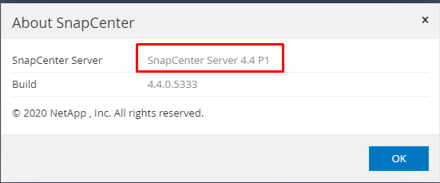

OR

# Setup

### Server Properties

Backup Server Properties determine how the plugin will interact with your SnapCenter server.

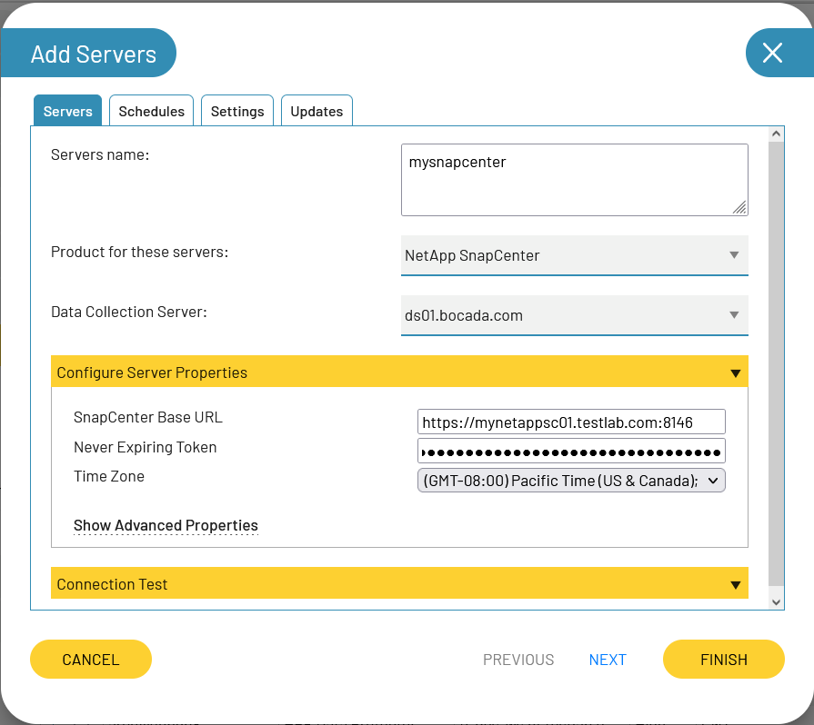

### Field Definitions

#### Servers name

Enter your preferred name for the server. It must be a single string with only letters, numbers, dot (.), hyphen (-), and underscore.

#### SnapCenter Base URL

*SnapCenter Base URL* is the URL of your SnapCenter Server host which you can copy from browser address bar. For example, https://your-host-name:portNumber. Make sure to also copy the API port number.

#### Never Expiring Token

Enter the Never Expiring Token that you generated from the SnapCenter REST API using the instructions below.

#### Time Zone

Select the time zone where SnapCenter server resides. This setting ensures times are displayed consistently in environments that span multiple time zones.

## Reporting Notes

As with the SnapCenter user console, byte counts are not available for NetApp SnapCenter backup jobs.

## Appendix A: Obtaining Never Expiring Token from SnapCenter

The never Expiring Token is value generated from SnapCenter REST API based on SnapCenter user credentials. To generate it please open your SnapCenter Server Base URL in browser paste “*/swagger”* string after it and hit Enter.

For example: <https://mysnapcenter.myco.com:8146/swagger>

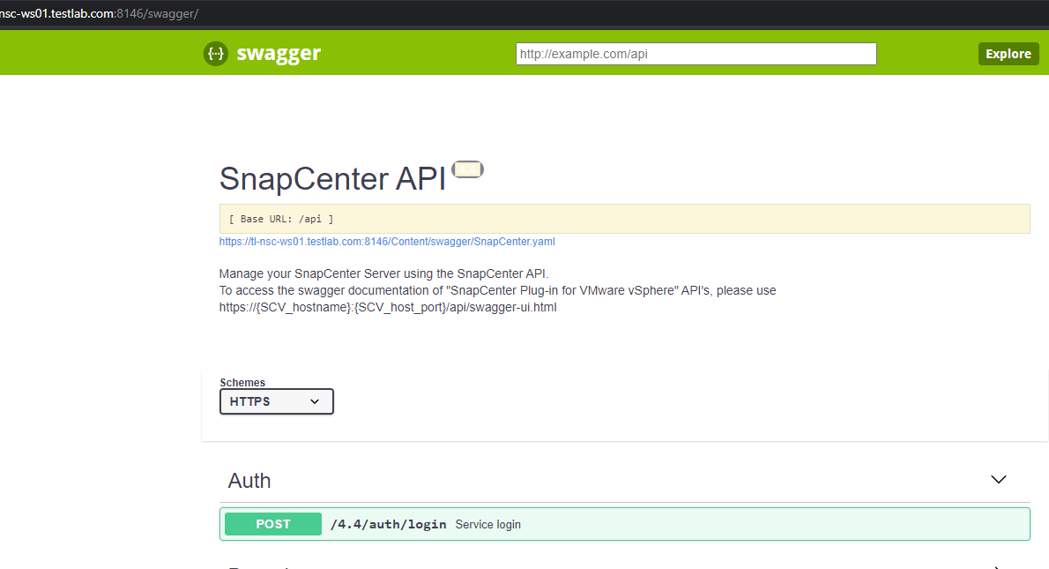

Click on “*auth/login”* then *“Try it out”:*

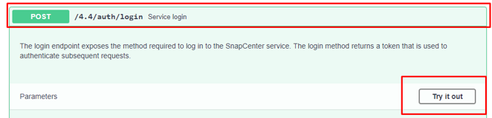

Set “*TokenNeverExpires*” value to “*true*”, *“Name”(SnapCenter Username), "Passphrase"(SnapCenter Password).* Remove *“"Rolename": "string*"” and “,” after “*Passphrase*” so model should be like on screenshot*:*

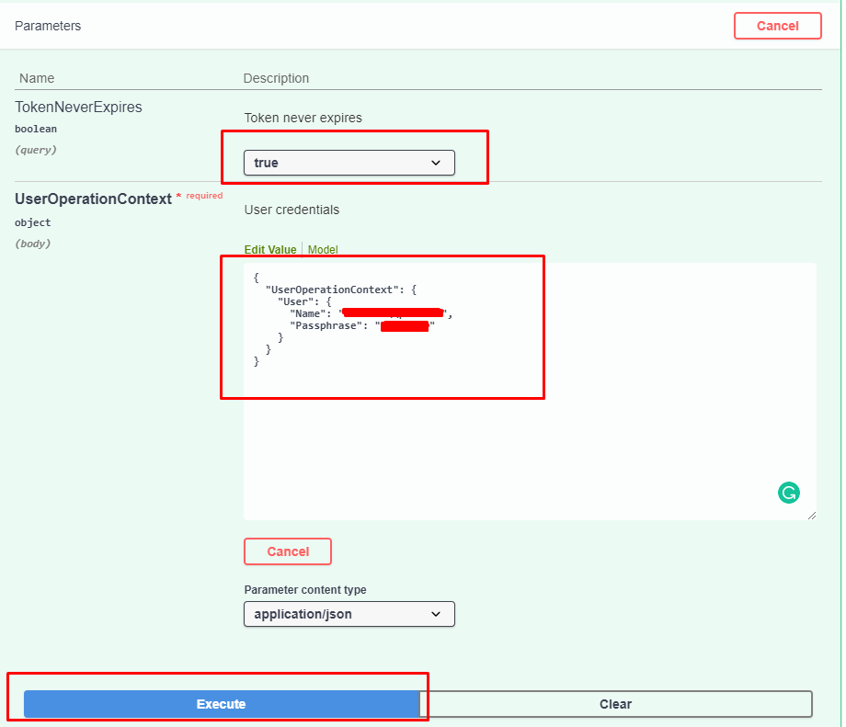

Click “Execute” button, scroll down after execution and copy “Token” value which is “Never Expiring Token” for SnapCenter plugin:

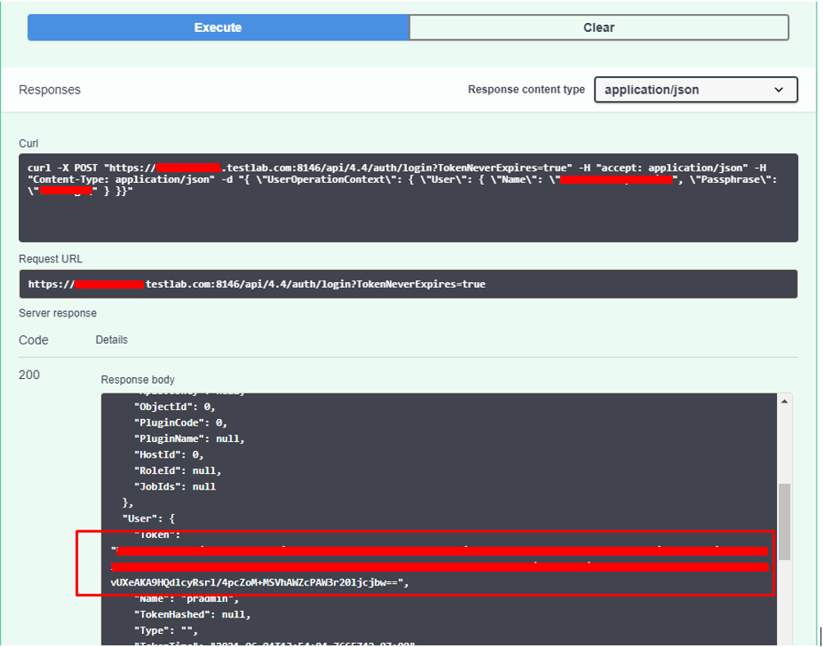

**Important:** The permissions associated with the token will be linked with the user that had at the time of the token creation. If the user's role is changed or the permissions are updated, a new token is required.

# Technical Support

For technical support or a copy of our standard support agreement, please contact us.

**E-mail:** [support@bocada.com](mailto:support@bocada.com)

**Support Portal:** [https://bocada-support.force.com](https://bocada-support.force.com/)

**Phone:** +1-425-898-2400

**Copyright © 2021 Bocada LLC.** All Rights Reserved. Bocada and BackupReport are registered trademarks of Bocada LLC. Vision, Prism, vpConnect, and the Bocada logo are trademarks of Bocada LLC. Other product names mentioned herein may be trademarks or registered trademarks of their respective companies.

Protected by U.S patents 6,640,217; 6,708,188; 6,745,210; 7,457,833; 7,469,269; 7,496,614; 8,407,227

The material in this manual is for information only and is subject to change without notice. While efforts have been made to ensure accuracy, Bocada LLC assumes no liability resulting from errors or omissions in this document, or from the use of information contained herein.

Bocada LLC reserves the right to make changes in the product design and documentation without reservation and without notification to its users. 8